**Assignment No. 02**

**Title:** [**Web Design and Programming Lab-I**](https://classroom.google.com/u/2/c/Njc5NTg4OTk0MTU0)

*Course title: Structured Programming Language*

*Course code: CSE-312*

*3rd Year 1st Semester Examination 2023*

**Date of Submission**: 01-Sep-2024



**Submitted to-**

###### **Md. Rafsan Jani**

*Assistant Professor*

*Department of Computer Science and Engineering*

*Jahangirnagar University*

*Savar, Dhaka-1342*

|  |  |  |  |
| --- | --- | --- | --- |
| **Sl** | Class Roll | Exam Roll | Name |
| 01 | 383 | 210903 | Abdullah Nazmus-Sakib |

|  |
| --- |
| **Problem Number:02** |

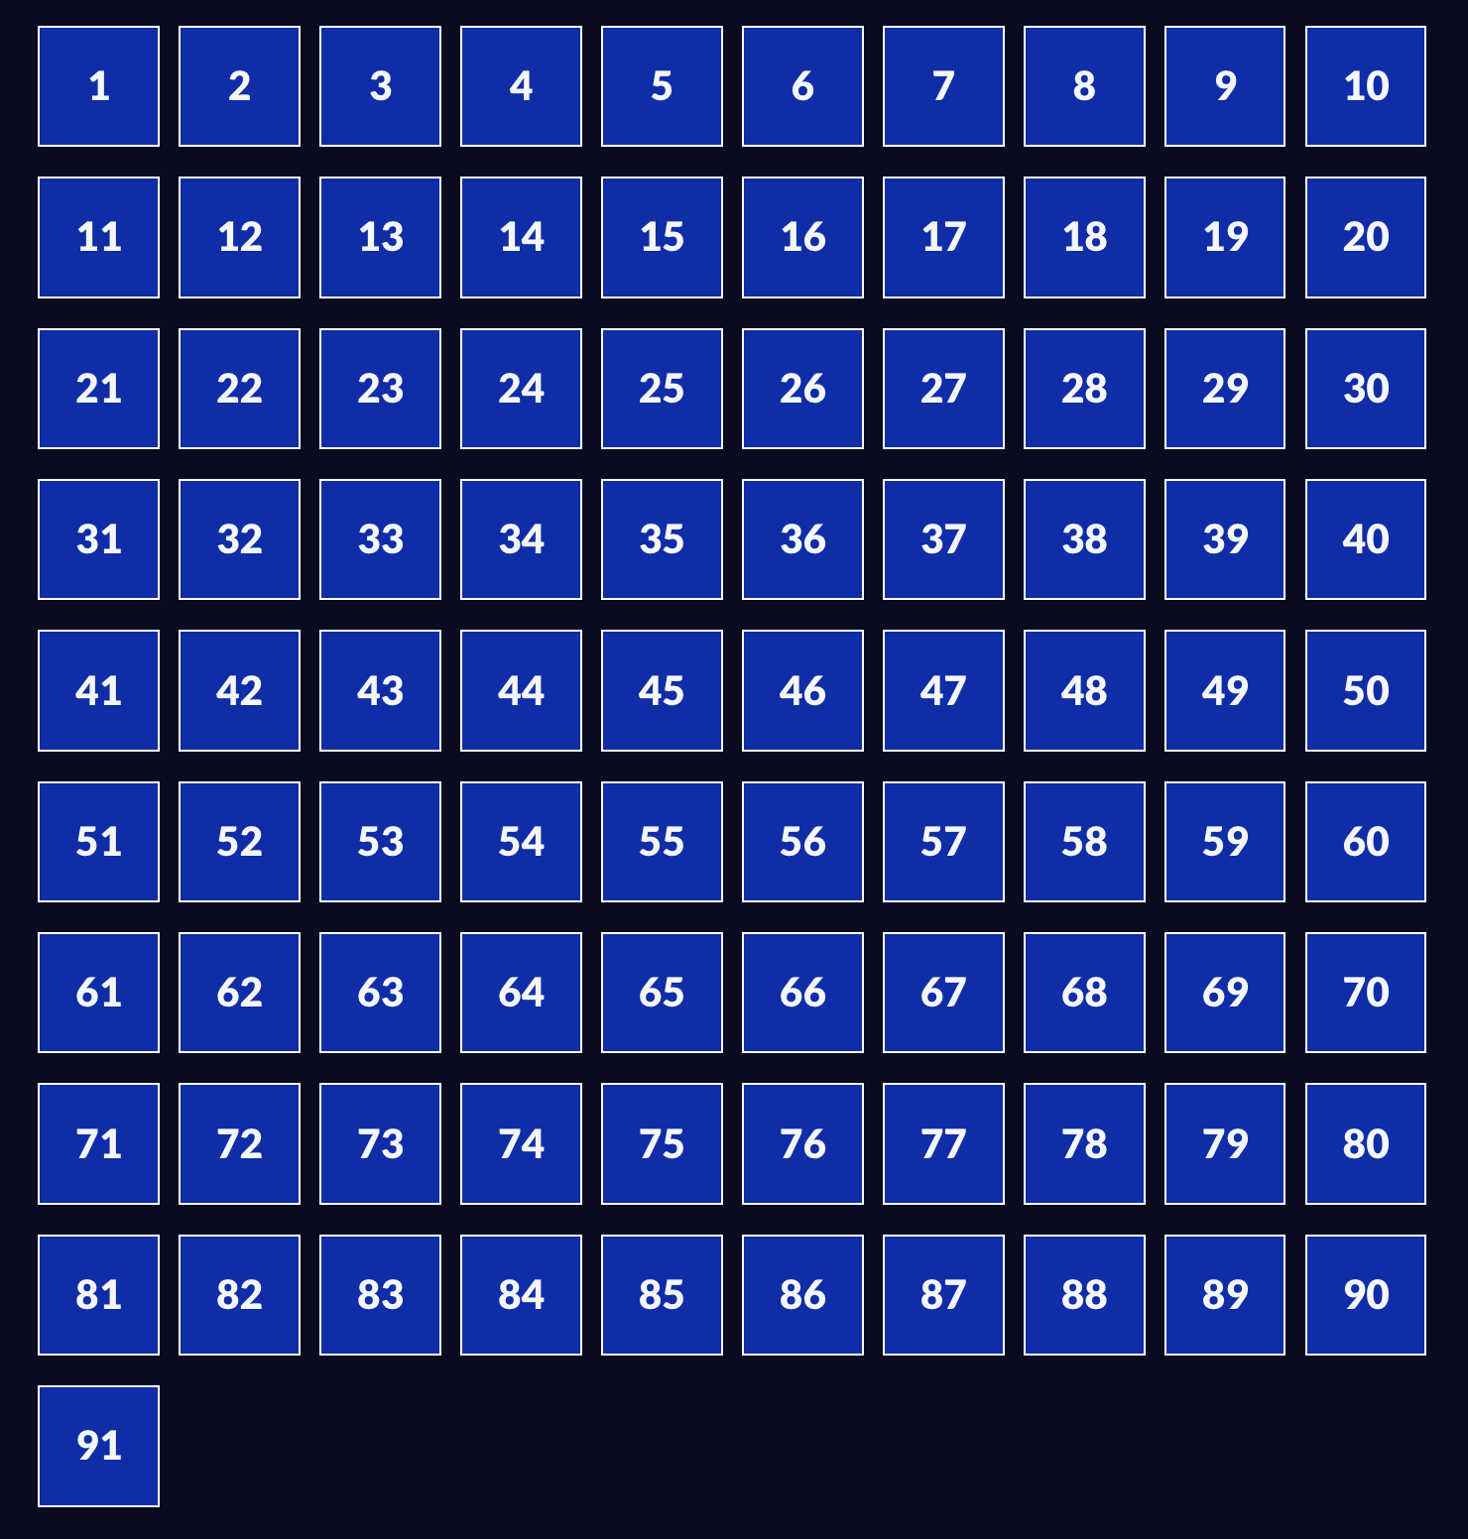

|  |
| --- |
| **Problem Number:2** |

Source Code:

Index.html

<!DOCTYPE html>

<html lang="en">

<head>

<meta charset="utf-8" />

<meta name="viewport" content="width=device-width, initial-scale=1.0" />

<title>Cafe Menu</title>

<link href="styles.css" rel="stylesheet"/>

</head>

<body>

<div class="menu">

<main>

<h1>CAMPER CAFE</h1>

<p class="established">Est. 2020</p>

<hr>

<section>

<h2>Coffee</h2>

<img src="https://cdn.freecodecamp.org/curriculum/css-cafe/coffee.jpg" alt="coffee icon"/>

<article class="item">

<p class="flavor">French Vanilla</p><p class="price">3.00</p>

</article>

<article class="item">

<p class="flavor">Caramel Macchiato</p><p class="price">3.75</p>

</article>

<article class="item">

<p class="flavor">Pumpkin Spice</p><p class="price">3.50</p>

</article>

<article class="item">

<p class="flavor">Hazelnut</p><p class="price">4.00</p>

</article>

<article class="item">

<p class="flavor">Mocha</p><p class="price">4.50</p>

</article>

</section>

<section>

<h2>Desserts</h2>

<img src="https://cdn.freecodecamp.org/curriculum/css-cafe/pie.jpg" alt="pie icon"/>

<article class="item">

<p class="dessert">Donut</p><p class="price">1.50</p>

</article>

<article class="item">

<p class="dessert">Cherry Pie</p><p class="price">2.75</p>

</article>

<article class="item">

<p class="dessert">Cheesecake</p><p class="price">3.00</p>

</article>

<article class="item">

<p class="dessert">Cinnamon Roll</p><p class="price">2.50</p>

</article>

</section>

</main>

<hr class="bottom-line">

<footer>

<p>

<a href="https://www.freecodecamp.org" target="_blank">Visit our website</a>

</p>

<p class="address">123 Free Code Camp Drive</p>

</footer>

</div>

</body>

</html>

Styles.cc

body {

background-image: url(https://cdn.freecodecamp.org/curriculum/css-cafe/beans.jpg);

font-family: sans-serif;

padding: 20px;

}

h1 {

font-size: 40px;

margin-top: 0;

margin-bottom: 15px;

}

h2 {

font-size: 30px;

}

.established {

font-style: italic;

}

h1, h2, p {

text-align: center;

}

.menu {

width: 80%;

background-color: burlywood;

margin-left: auto;

margin-right: auto;

padding: 20px;

max-width: 500px;

}

img {

display: block;

margin-left: auto;

margin-right: auto;

}

hr {

height: 2px;

background-color: brown;

border-color: brown;

}

.bottom-line {

margin-top: 25px;

}

h1, h2 {

font-family: Impact, serif;

}

.item p {

display: inline-block;

margin-top: 5px;

margin-bottom: 5px;

font-size: 18px;

}

.flavor, .dessert {

text-align: left;

width: 75%;

}

.price {

text-align: right;

width: 25%;

}

/* FOOTER */

footer {

font-size: 14px;

}

.address {

margin-bottom: 5px;

}

a {

color: black;

}

a:visited {

color: black;

}

a:hover {

color: brown;

}

a:active {

color: brown;

}

|  |
| --- |
| **Problem Number:03** |

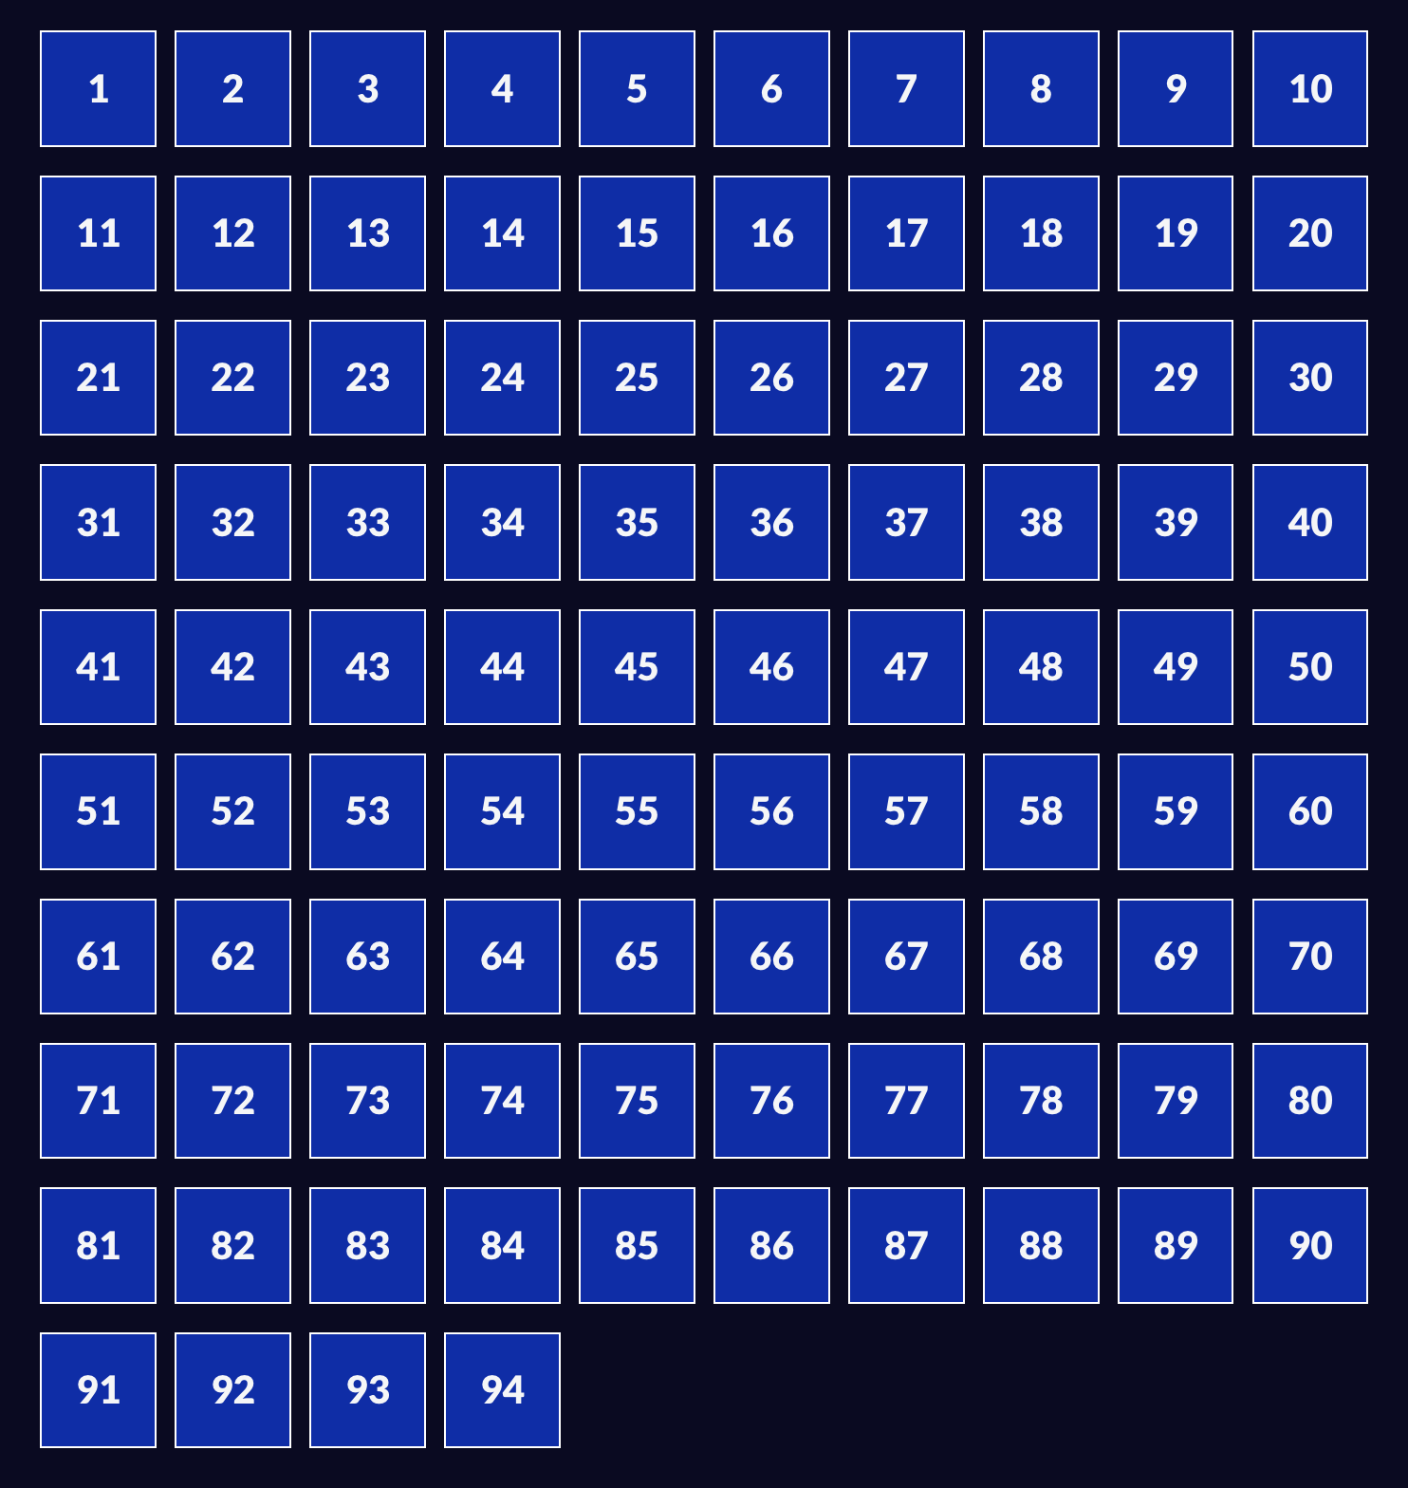

Source Code:

Index.html

<!DOCTYPE html>

<html lang="en">

<head>

<meta charset="utf-8">

<meta name="viewport" content="width=device-width, initial-scale=1.0">

<title>Colored Markers</title>

<link rel="stylesheet" href="styles.css">

</head>

<body>

<h1>CSS Color Markers</h1>

<div class="container">

<div class="marker red">

<div class="cap"></div>

<div class="sleeve"></div>

</div>

<div class="marker green">

<div class="cap"></div>

<div class="sleeve"></div>

</div>

<div class="marker blue">

<div class="cap"></div>

<div class="sleeve"></div>

</div>

</div>

</body>

</html>

Styles.css

h1 {

text-align: center;

}

.container {

background-color: rgb(255, 255, 255);

padding: 10px 0;

}

.marker {

width: 200px;

height: 25px;

margin: 10px auto;

}

.cap {

width: 60px;

height: 25px;

}

.sleeve {

width: 110px;

height: 25px;

background-color: rgba(255, 255, 255, 0.5);

border-left: 10px double rgba(0, 0, 0, 0.75);

}

.cap, .sleeve {

display: inline-block;

}

.red {

background: linear-gradient(rgb(122, 74, 14), rgb(245, 62, 113), rgb(162, 27, 27));

box-shadow: 0 0 20px 0 rgba(83, 14, 14, 0.8);

}

.green {

background: linear-gradient(#55680D, #71F53E, #116C31);

box-shadow: 0 0 20px 0 #3B7E20CC;

}

.blue {

background: linear-gradient(hsl(186, 76%, 16%), hsl(223, 90%, 60%), hsl(240, 56%, 42%));

box-shadow: 0 0 20px 0 blue;

}